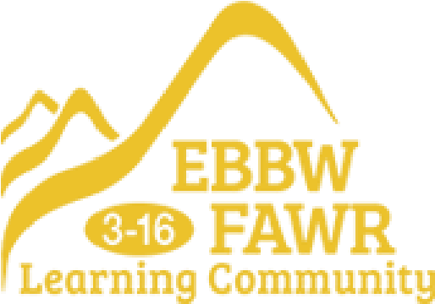

**Cymuned Ddysgu Ebbw Fawr**

Ebbw Fawr Learning Community



**Pupil Development Grant Strategy**

**Statement**

**2025-2026**

**PUPIL DEVELOPMENT GRANT STRATEGY STATEMENT**

This statement details our school’s use of the PDG for the 2025 to 2026 year.

It outlines our strategy, how we intend to spend the funding in this academic year and the effect that last year’s spending had within our school.

*\* January 2024 figure*

**School Overview**

Number of pupils in school* 1407

Proportion (%) of PDG eligible pupils* 24.02%

Date this statement was published 10th September 2025

Date on which it will be reviewed 12th January 2026

**Funding Overview**

PDG funding allocation this academic year £420,894

**Part A: Strategy Plan**

Intended Outcomes

* Development of enhanced EVE offsite provision for KS4 learners with improved outcomes
* Focus on attendance and behaviour particularly eFSM learners by Family Engagement Officers and designated senior staff across the whole school
* Supporting RADY activities including uniform support, resources and trips for parents/families across whole school
* Supporting RADY curriculum activities across whole school
* Additional support for Pastoral Management Team in Secondary Phase
* Additional Teaching Assistant focusing on small group interventions
* Improving reading scores against chronological age across 3-16.